

Hallbankgate Hub Limited
A Community Benefit Society, run by the community for the community
Volunteer Agreement

Hallbankgate Hub Limited: Volunteer Agreement: Spring 2016: updated Autumn 2021
This agreement sets out what we can each reasonably expect from your volunteering role within Hallbankgate Hub Limited (the “Hub”). The Hub appreciates you volunteering with us and is committed to providing a supportive environment for volunteers. We hope that you will find your volunteer experience enjoyable and rewarding.

Volunteer role
Your role as volunteer will start on [DATE]. New volunteers will have a meeting with the Volunteer Coordinator to discuss when you will be able to volunteer and the type of tasks you would like to do. We hope that you will be able to volunteer on a regular basis and understand if you prefer to be on a stand-by list. There will be a standby list of those willing to be contacted at short notice to cover sickness, holidays etc.
We expect you to perform your role to the best of your ability and to follow our procedures and standards, including health and safety. You can expect us to deal with you in accordance with our Equal Opportunities Policy.

Induction and training
We will provide an induction explaining what we do and how volunteers fit within our organisation. We will also provide training to assist you to meet the standards we expect from volunteers and to ensure your health and safety.

Supervision and support
The Hub Manager (or his/her delegated assistant) is responsible for managing and supervising your work as a volunteer when you are in the Hub itself.
Your main point of contact for all other aspects of your volunteering with us will be the Volunteer Coordinators. You are welcome to set up regular meetings with the Volunteer Coordinators to discuss your work and targets if you would like a more formal structure

Expenses
We will reimburse pre-approved out-of-pocket expenses incurred as a result of agreed business activity. An email from the Hub Manager or Committee member which pre-dates the expense will be required.

Insurance
The Hub provides adequate insurance cover for you while you are undertaking voluntary work approved and authorised by us.

Confidentiality
In the course of providing your volunteering services, you may have access to confidential information relating to the Hub, our staff, the Management Committee, customers and other volunteers. We expect you not to use or disclose this information to any person either during your volunteering experience with us or at any time afterwards.

Leaving
We ask that you give us as much notice as possible if you want to stop volunteering with us.

This agreement is binding in honour only, is not intended to be a legally binding contract between us and so may be cancelled at any time at the discretion of either party. Neither you as a volunteer nor us as ‘The Hub’ intends any paid employment relationship to be created either now or at any time in the future.
Please acknowledge that you understand the contents of this agreement by signing, dating and returning the Agreement. Please send digitally if possible or drop a copy into the Hub for the attention of the Volunteer Coordinator.
volunteer@hallbankgatehub.com
Yours sincerely

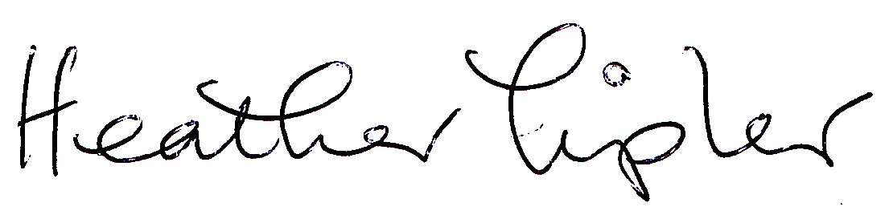

Heather Tipler
Volunteer Coordinator (July 21 – Jan 22)
On behalf of Hallbankgate Hub Limited

I understand the contents of this agreement and confirm that I have been provided with the following documents as part of my induction:

- Health and Safety Policy
- Equal Opportunities Policy
- Volunteer Policy

Signed
[NAME OF VOLUNTEER]

Date

